Setting up Otus with NI Traktor 3 (Windows computers)
Assuming that the EKS Driver Pack and Traktor 3 have been installed, here are the steps how to set up a single Otus controller with Traktor 3.

Choose MIDI mapping
Click the EKS MIDI Agent icon from the taskbar using the right mouse button and choose Traktor mapping from the menu.
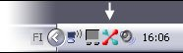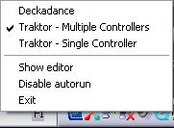

Load Traktor MIDI settings
- Launch Traktor 3
- Open preferences
- Open “Hotkey & Midi Setup” menu
- Open “MIDI Interfaces” panel. 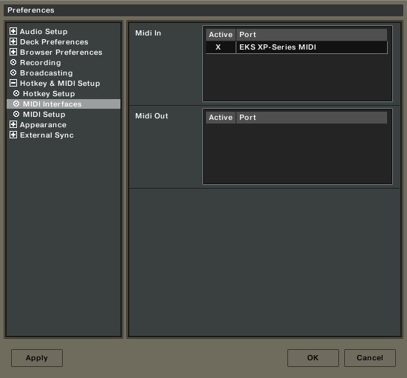
- Make sure that “EKS XP-Series MIDI” has been activated.
- Open “MIDI Setup” panel.
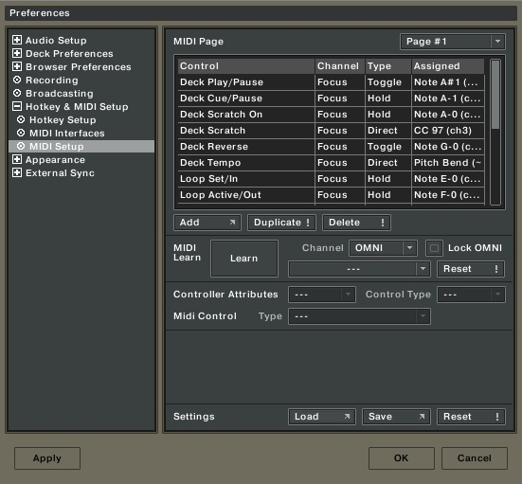
- Click the “Load” button from bottom of the panel
- Browse and load a file titled “TDJS3 EKS MIDI Otus Single Internal Mixer.tks” from
“C:\Program Files\Common Files\EKS\3rd Party\Traktor3” -directory
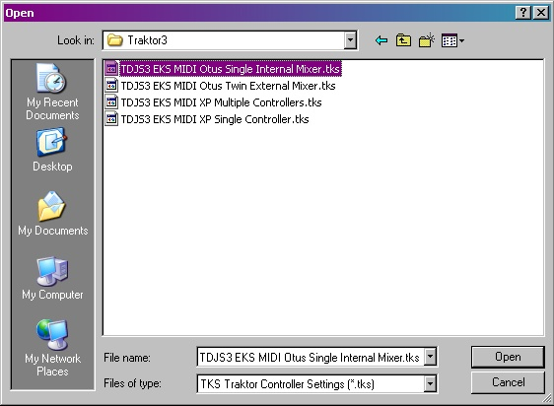

- Check out the mapped configuration (pdf): Traktor3_Single_Internal_Mixer.pdf

Set up audio
Open "Soundcard" from Preferences -> Audio Setup. Select "EKS ASIO" as you audio device.
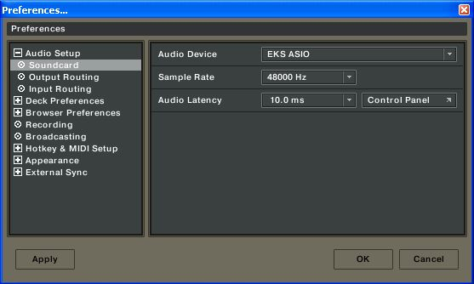
The EKS ASIO driver should automatically make the correct settings, but if you want to doublecheck this or to make your own channel settings, open up the control panel from Preferences -> Audio Setup -> Soundcard and check that the ASIO settings are as follows:
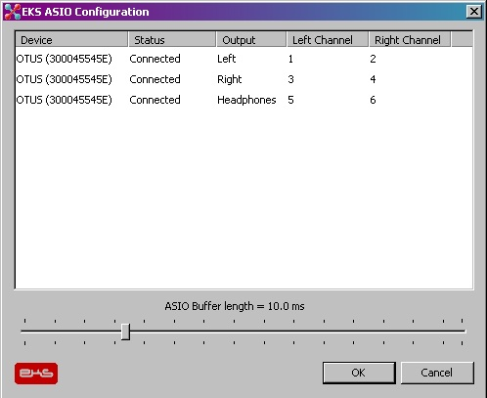
Then go to "Output Routing", select "External" and set the output channels as follows:
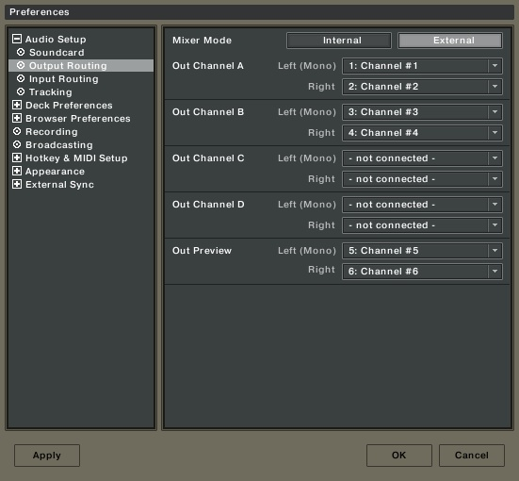
OR if you want to use Traktor's internal mixer:
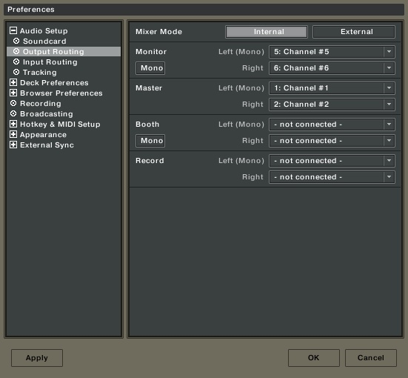
Now you can start using Traktor 3 with your Otus controller.

